Please find the attached management pack and csv file for port monitoring.

 

Steps to be followed:

1. Import the management pack
2. Create a file share and create a file TCPMonitoringConfig.csv ( I have created a file share as [\\SCOMMS1\Software\TCPMonitoringConfig.csv](file:///\\SCOMMS1\Software\TCPMonitoringConfig.csv))
3. Put the required information in TCPMonitoringConfig.csv file as below.

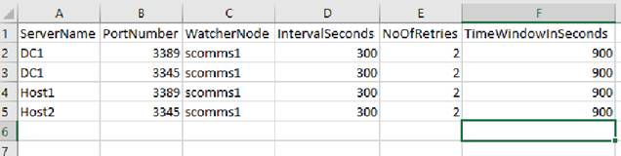

1. Create an overrides and change the FilePath below with the Fileshare which you have created in FilePath.

